What is the difference between stroph robustus and anoplocapros inermis according to Winterbottom & tyler?
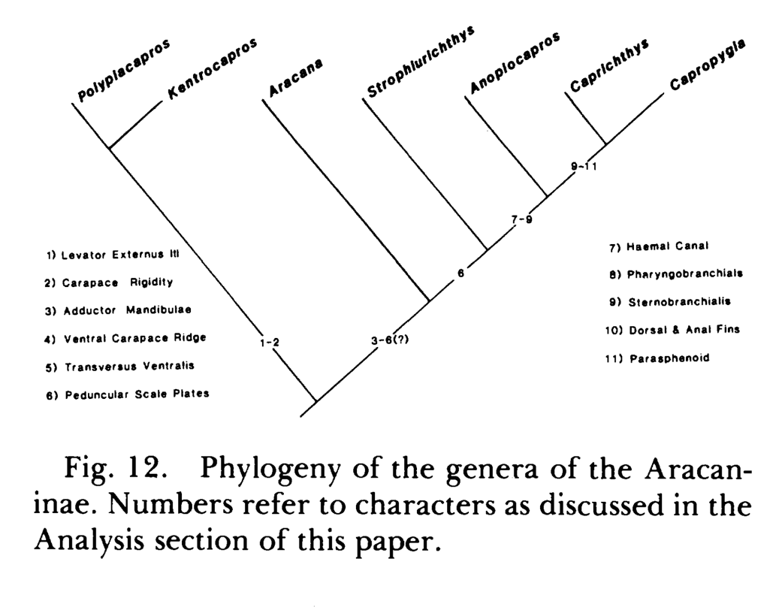
The differences are in traits 7, 8, and 9: haemal canal, pharyngobranchialis, and sternobranchialis
And also the bony plates on caudal peduncle
Strophiurichthys: ONLY 2 pairs of triangular saddles from lateral view
Anoplocapros: anterior pair of saddles do not touch along the lateral midline, but posteriorly they form a COMPLETE bony ring (Winterbottom & tyler 1983, tyler 1980) “Anoplocapros differs from Strophiurichthys mainly in having a complete ring of scales around the posterior region of the caudal peduncle instead of two saddles. However, this is surely a minor distinction, and McCulloch and Waite (1915:479) pointed out that the ring"may be incomplete in the young "” -tyler 1980

“Strophiurichthys and Kentrocapros have the ventral edge ofthe parasphenoid the least expanded in the family, and Strophiurichthys has the best developed dentition on the two pharyngobranchials (third and fourth) bearing large teeth, as well as minute teeth on the second pharyngobranchial. Kentrocapros has minute teeth on the second pharyngobranchial but fewer large teeth on the third and fourth pharyngobranchials than in Strophiurichthys. Strophiurichthys has a high dorsal crest, similar inmagnitude to that of Proaracana if the high dorsal spiny process in the latter is ignored.” Tyler 1980

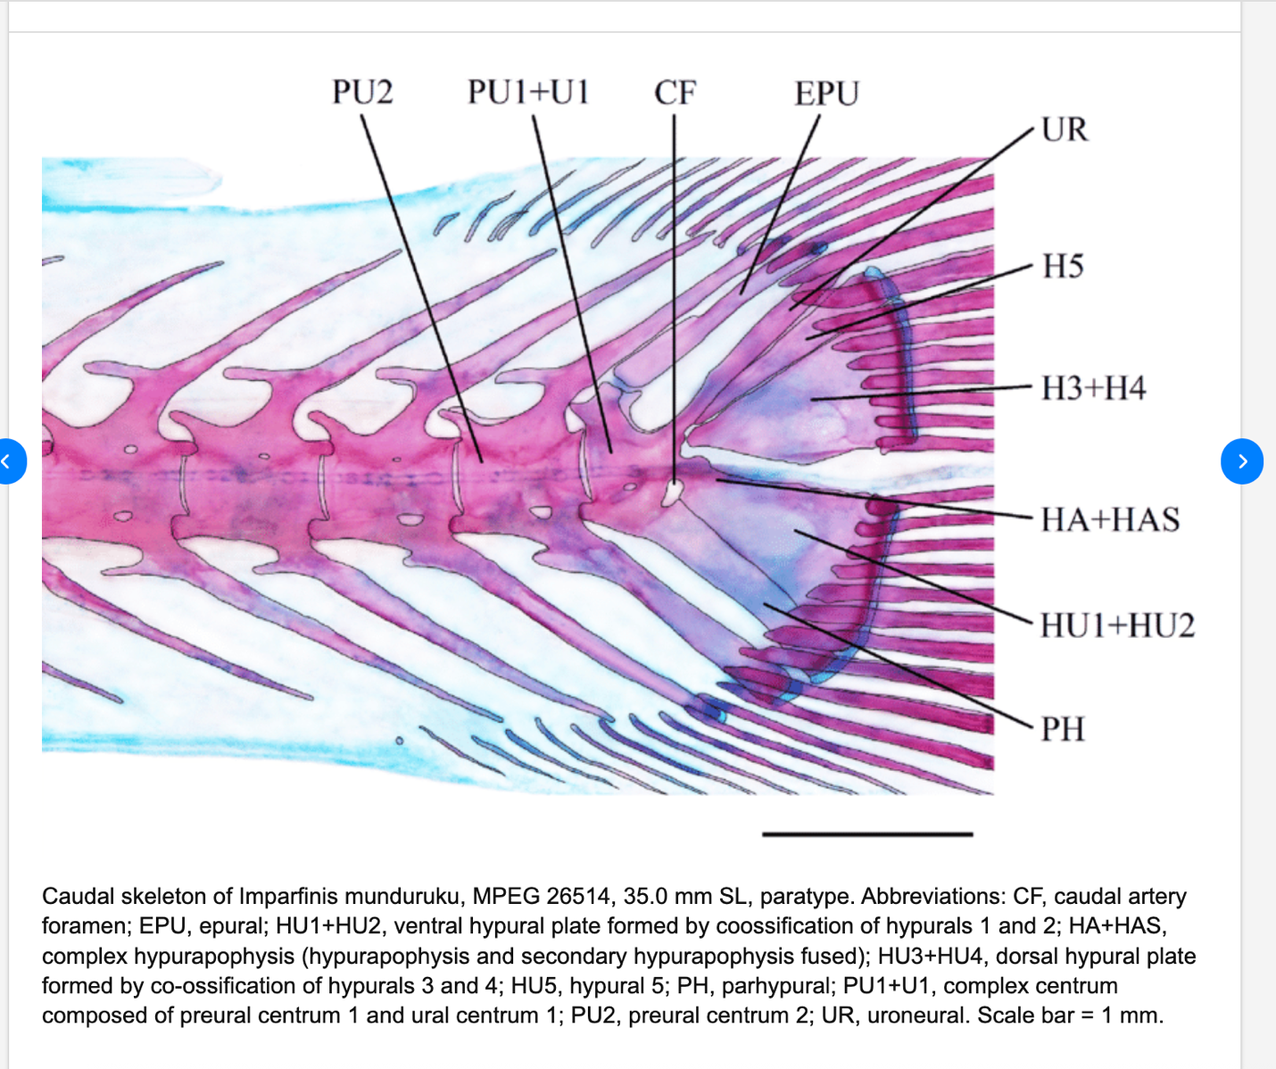
https://www.researchgate.net/figure/Caudal-skeleton-of-Imparfinis-munduruku-MPEG-26514-350-mm-SL-paratype-Abbreviations_fig2_337701297
foramen refers to CF? in anoplocapros, there is no foramen.

9 sternobranchialis (STB)
From polyplacapros to strophiurichthys, the sternobranchialis muscle fibers form a single bundle which grades into an aponeurosis. An anterior and posterior tendon arise from the aponeurosis to insert into the hypo and cerato branchial elements of the gill arches
- Strophiurichthys: Single muscle fiber aponeurosis ant. & pos. tendon that connect to hypobranchial bone & ceratobranchial bone in gill arches
- Anoplocapros: dorsal half of STB muscle has ant. & pos. sections which grade into respective tendons. Ventral half of STB is singular.
- Caprichthys + capropygia: ant. & pos. separation of muscle is complete
- Ostraciins: separation, where anterior is greatly enlarged
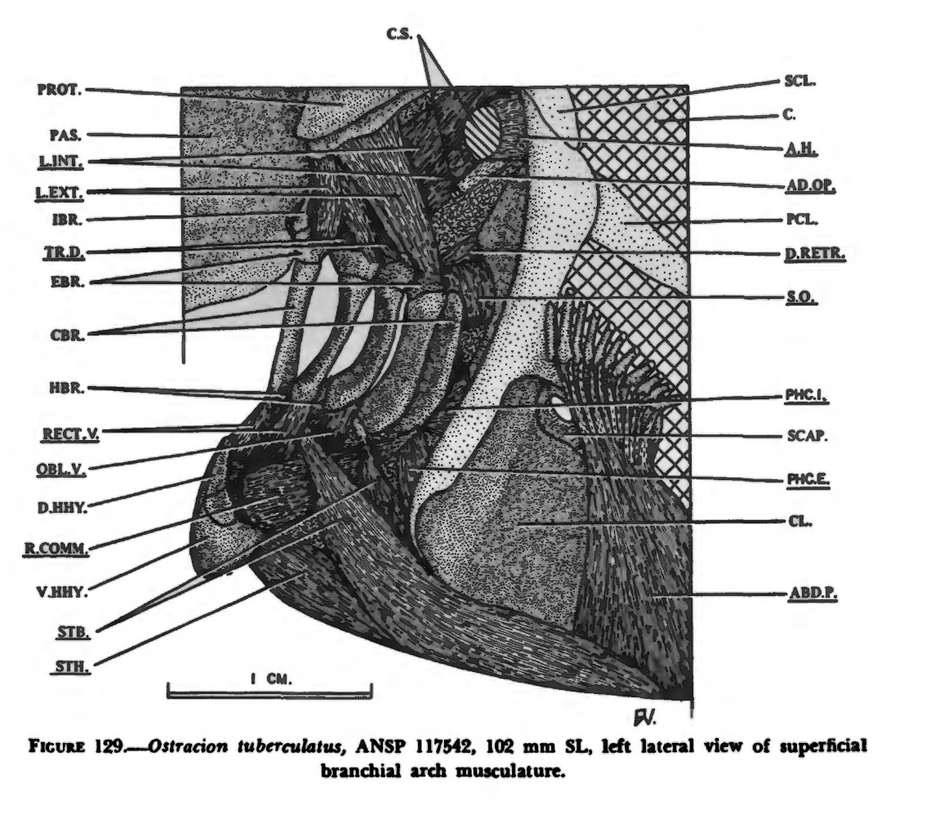
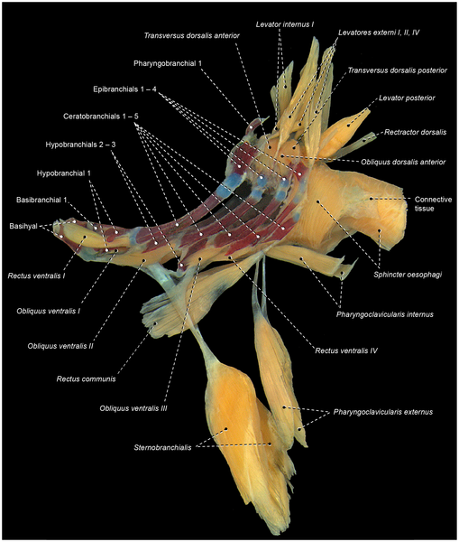 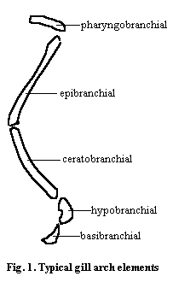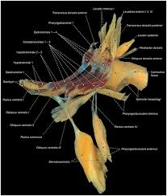509 × 600

